1. **Display Menu:**

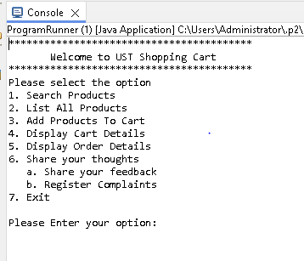

1. **Display all products:**

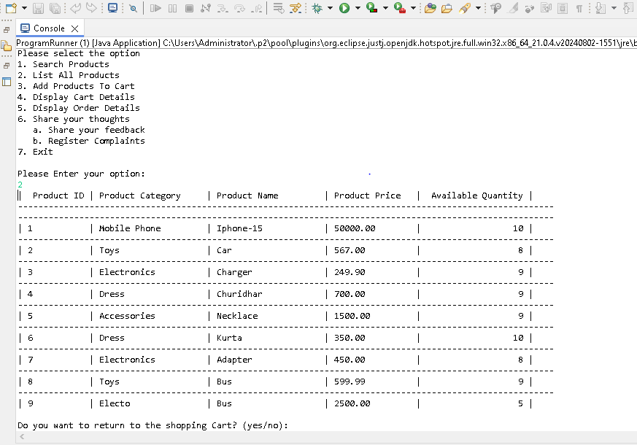

1. **a) Search products using the product name:**

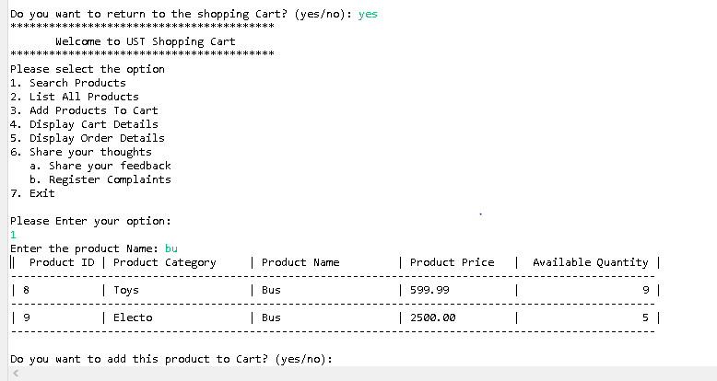

**b) After search add product to the Cart:**

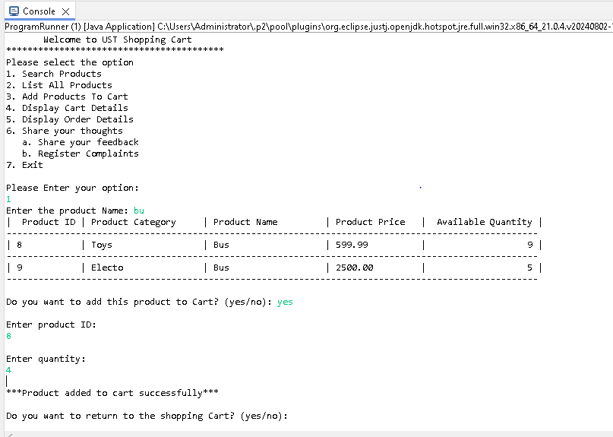

**4 a) add products to cart using the product id**

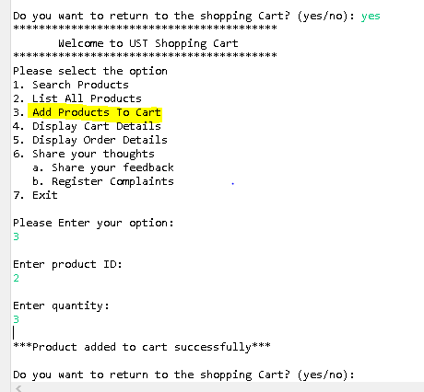

1. **Display cart details:**

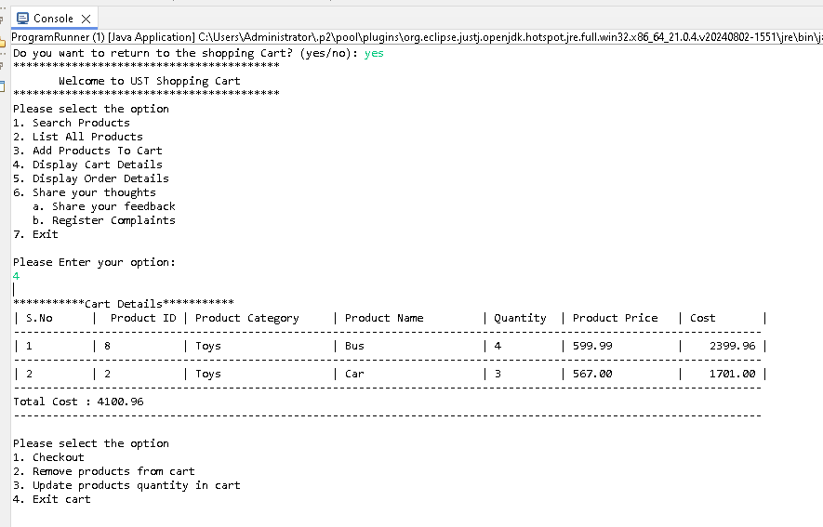

**6 a)Update the product quantity in cart:**

Cart before updating the product quantity and steps to update the quantity.

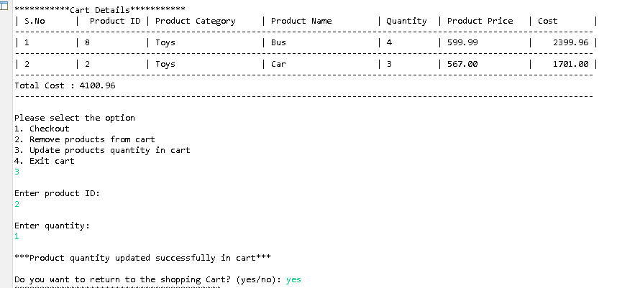

After quantity updated.

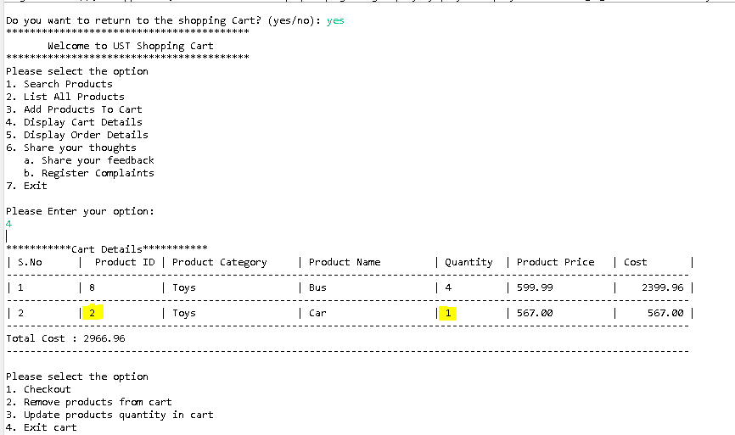

**b)Update product quantity with Zero:**

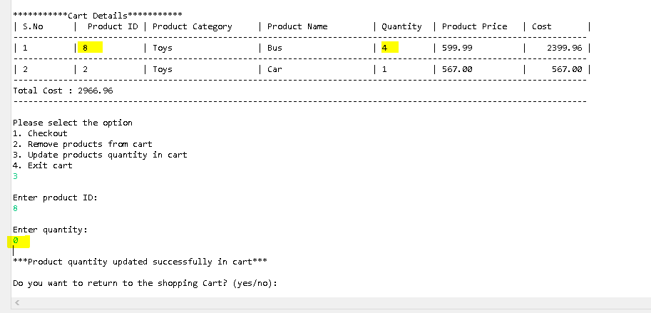

Products with Zero quantity will be removed from the Cart.

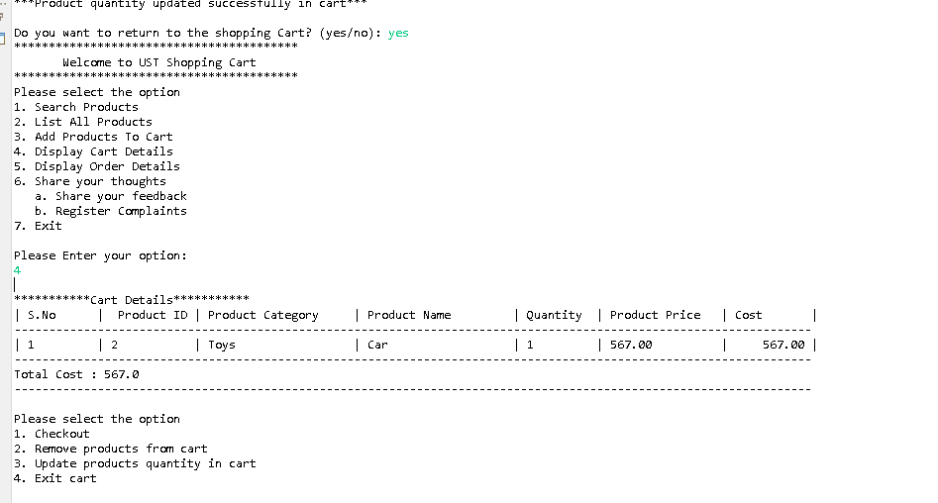

**7 Remove products from Cart:**

Note: Added 2 more products to the Cart for testing.

Cart before remove the product:

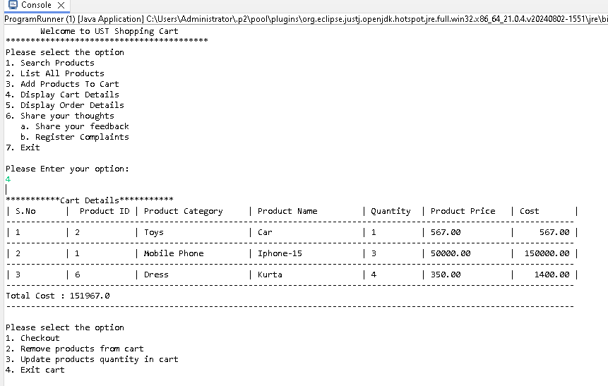

Cart after remove the product(Product ID =1):

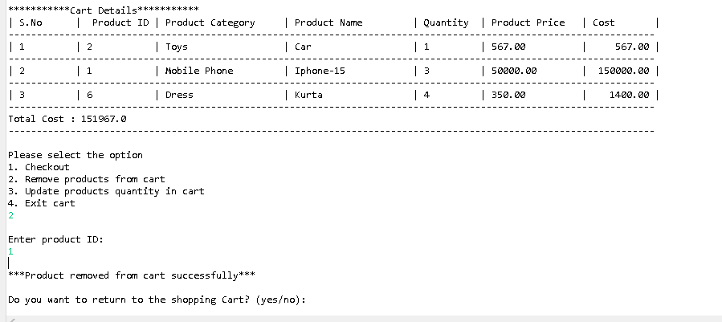

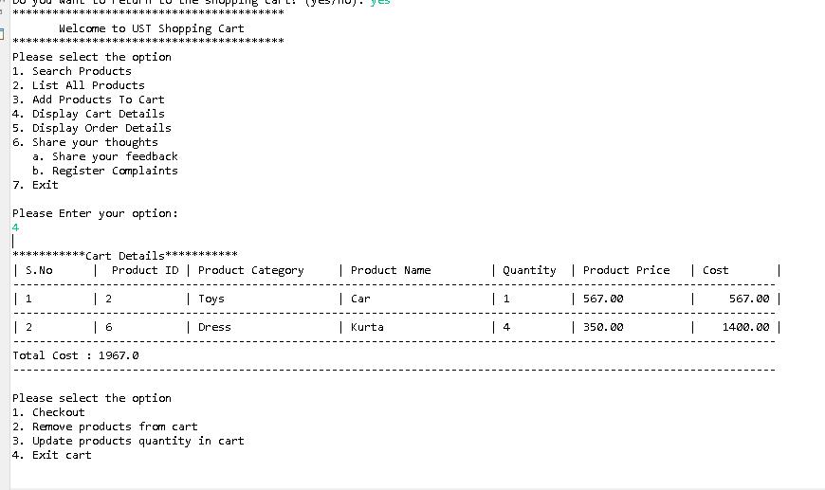

**8 Checkout:**

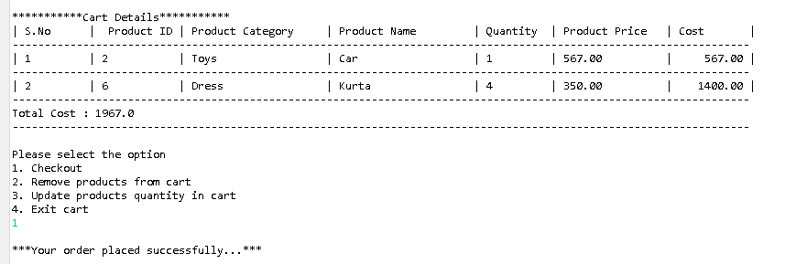

1. **Available quantity updated to the products list after products purchased:**

Products list before purchase :



Products List after purchase:

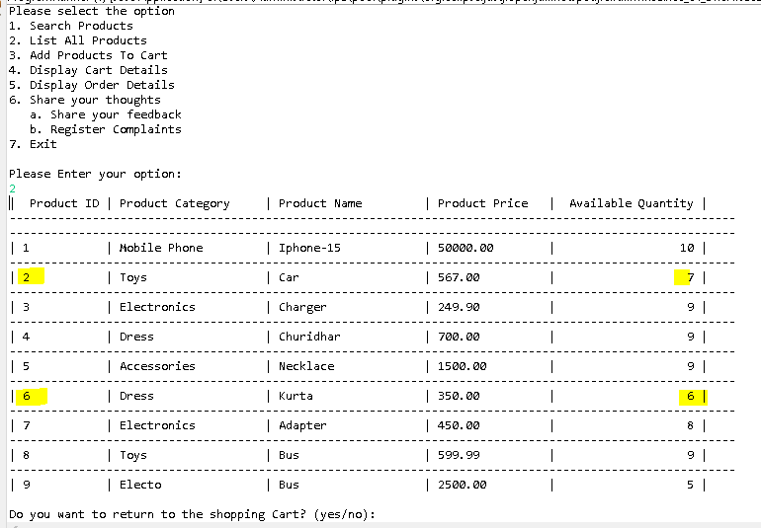

1. **Display Order Details :**

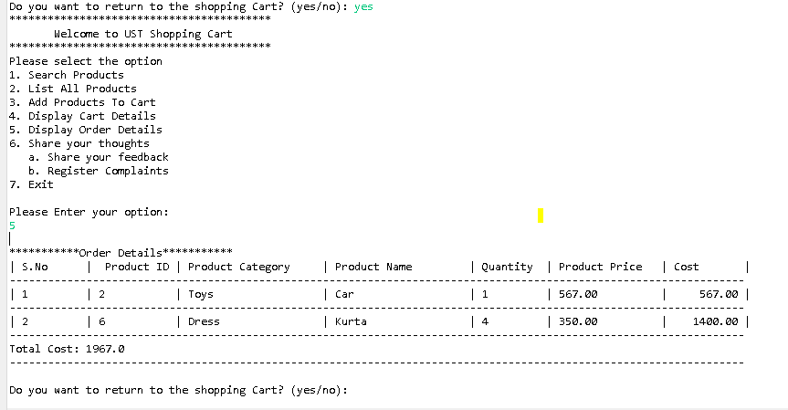

1. **Feedback and Complaints :**

**Feedback:**

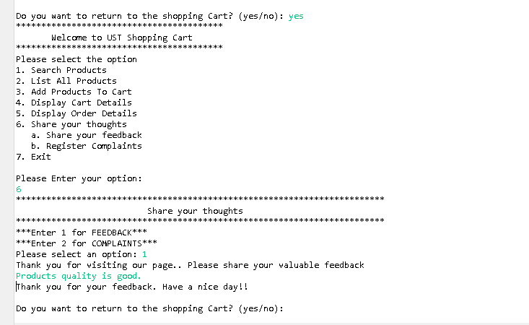

**Complaints:**

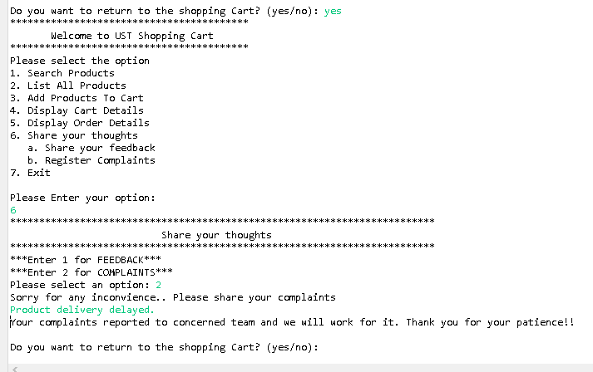

1. **Display cart details without adding any products to cart:**

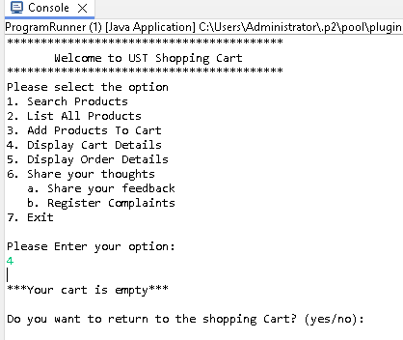

1. **Display order details without adding any products to orders**

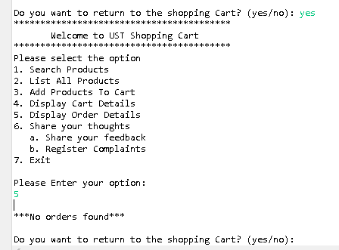

1. **Invalid product Search:**

Invalid search by product name:

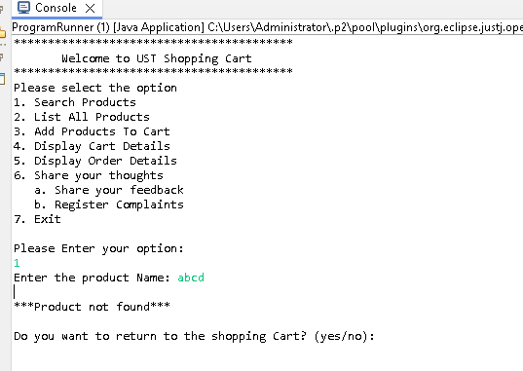

Invalid search by product ID:

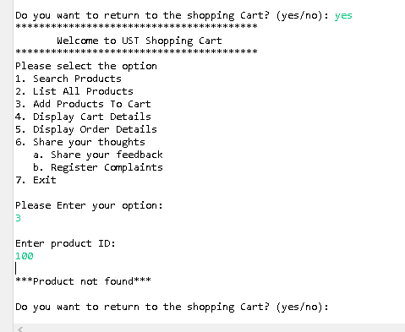

1. **Invalid entry when selecting menu option :**

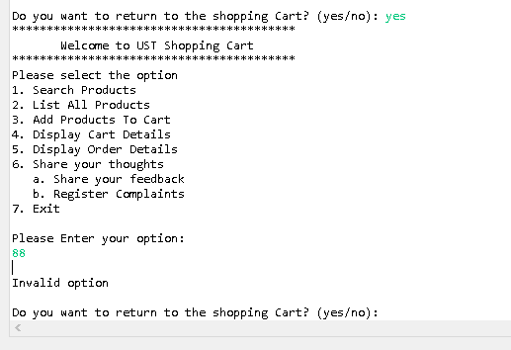

1. **Exit Menu :**

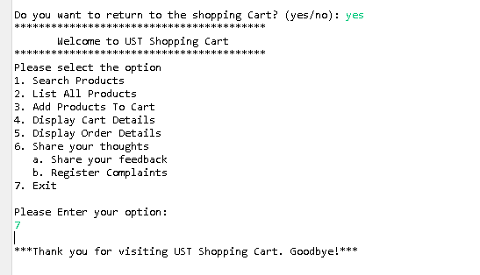

1. **Exit Cart :**

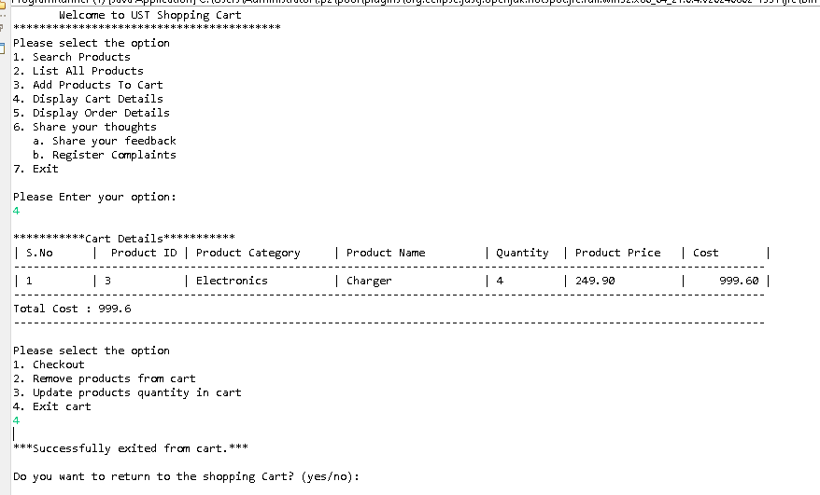

**18 a)Add products to database:**

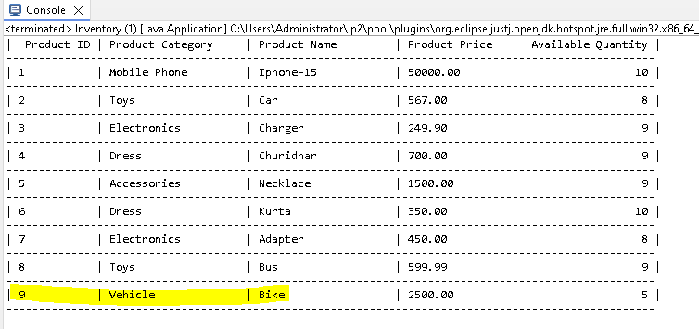

**b)Remove products to database:**

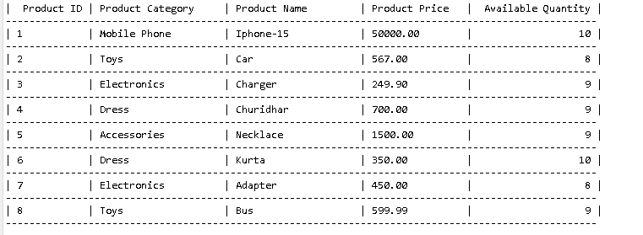

**19 Invalid Quantity entry :**

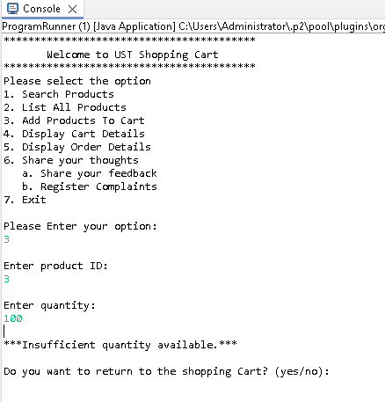

**20 Database :**

